Lecture 05: Specification Sheet

Topic: CSS Flexbox (display: flex & related properties)

1. Learning Objectives
After completing this lecture, students must be able to:
- Understand the concept of Flexbox layout
- Use display: flex to create flexible layouts
- Control alignment using justify-content and align-items
- Change layout direction with flex-direction
- Apply flex-grow, flex-shrink, and flex-basis
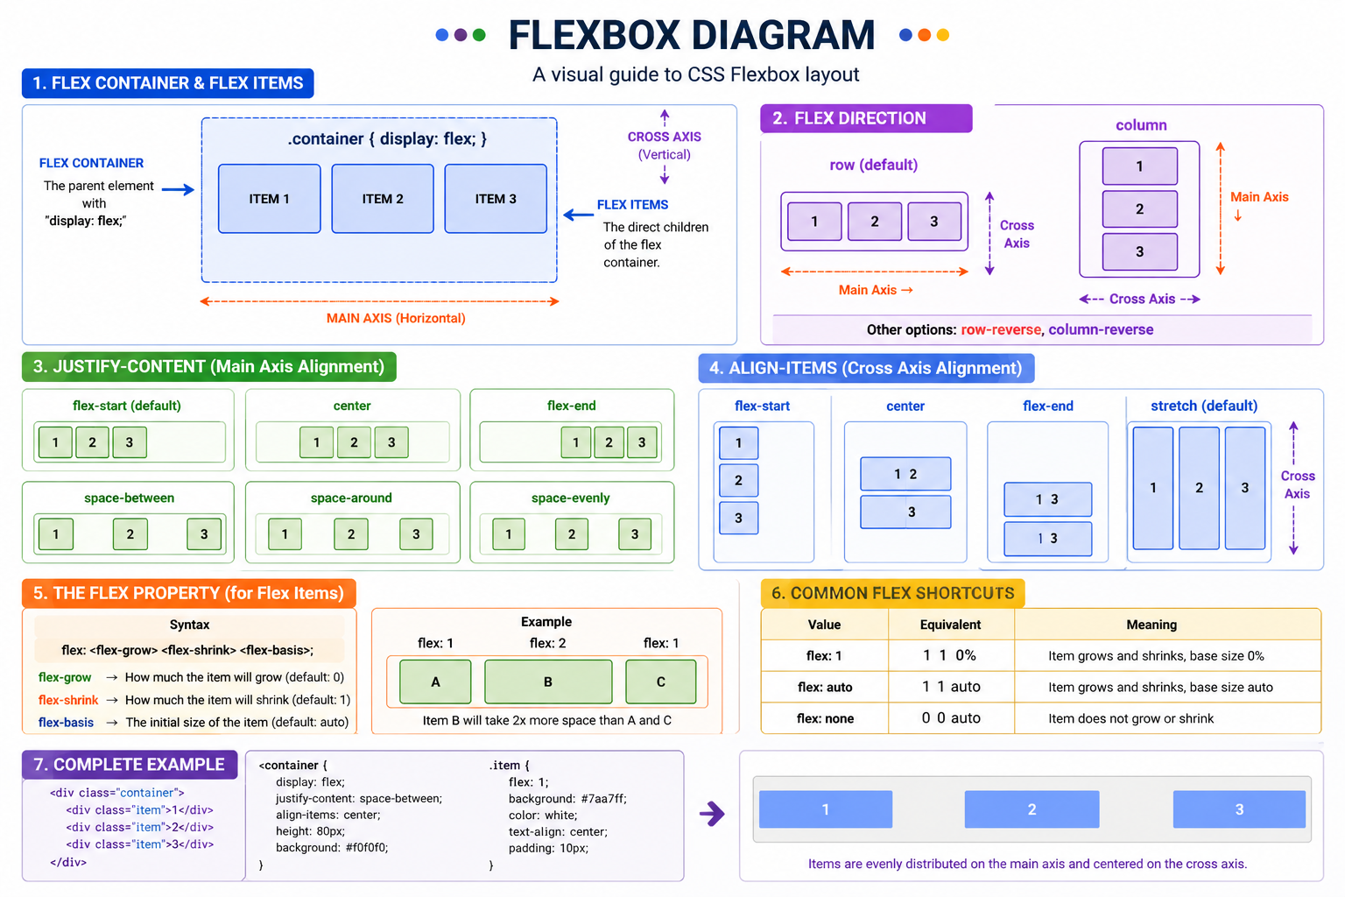

2. Key Concepts & Specifications

2.1 display: flex
- Defines a flex container
- Activates Flexbox layout for child elements
Syntax:
.container {
display: flex;
}

Effect:
- All direct child elements become flex items
- Default direction is row (horizontal)

2.2 flex-direction
- Defines the direction of flex items
Values:
- row (default) → left to right
- row-reverse → right to left
- column → top to bottom
- column-reverse → bottom to top
Syntax:
.container {
flex-direction: row;
}

2.3 justify-content
- Aligns items along the main axis
Values:
- flex-start → start
- flex-end → end
- center → center
- space-between → equal space between
- space-around → space around items
- space-evenly → equal spacing
Syntax:
.container {
justify-content: center;
}

2.4 align-items
- Aligns items along the cross axis
Values:
- stretch (default)
- flex-start
- flex-end
- center
- baseline
Syntax:
.container {
align-items: center;
}

2.5 flex (grow, shrink, basis)
- A shorthand property for:
  - flex-grow
  - flex-shrink
  - flex-basis
Syntax:
.item {
flex: grow shrink basis;
}

2.5.1 flex-grow
- Defines how much an item will grow
- Default: 0
.item {
flex-grow: 1;
}

2.5.2 flex-shrink
- Defines how much an item will shrink
- Default: 1
.item {
flex-shrink: 1;
}

2.5.3 flex-basis
- Defines initial size before growing/shrinking
.item {
flex-basis: 200px;
}

Example (Combined)
.container {
display: flex;
flex-direction: row;
justify-content: center;
align-items: center;
}

.item {
flex: 1 1 200px;
}

3. Teaching Aids / Materials
- Computer with VS Code
- Browser (Chrome/Edge)
- Projector (optional)
- Live coding demonstration

4. Time Allocation
- Introduction: 10 minutes
- Concept Explanation: 25 minutes
- Practical Demo: 20 minutes
- Student Practice: 25 minutes
- Review & Q/A: 10 minutes

5. Assessment Criteria
Students will be evaluated based on:
- Correct use of display: flex
- Proper alignment using justify-content and align-items
- Correct use of flex-direction
- Proper application of flex properties

6. Expected Outcome
Students will be able to:
- Create responsive layouts using Flexbox
- Align elements horizontally and vertically
- Control spacing and sizing of elements dynamically

If you want, I can also create:
- Activity Sheet
- Job Sheet
- Self-Check Quiz
for this lecture.

